# Developing Educational Games: SELFISH

JasonPang

2034852

Project Dissertation



# Declaration

## Statement 1

This work has not been previously accepted in substance for any degree and is not being con- currently submitted in candidature for any degree.

Signed Jason Pang (2034852)

Date ............................................................

## Statement 2

This thesis is the result of my own investigations, except where otherwise stated. Other sources are acknowledged by citations giving explicit references. A bibliography is appended.

Signed Jason Pang(2034852)

Date ............................................................

## Statement 3

The University’s ethical procedures have been followed and, where appropriate, ethical approval has been granted.

Signed Jason Pang(2034852)

Date ............................................................

## Summary

Selfish is a game designed to study and educate around the self-fertilising fish Mangrove rivulus(Kryptolebias marmoratus), while keeping the fun of a game for the user.

The game present a simulation of ecological environment of the mangrove fish, where player will control one of the hermaphrodites mangrove fish in the environment and face on difficulties including avoid pathogens, finding food and reproduce etc. before dying from old age or infection. Given the variety of pathogens, one must at all cost avoid to get infect if the fish do not have the immunity, occasionally a male mangrove fish will appear, granting the player an option to increase virus immunity by outcrossing with it. With such factors, player will immerse into the experience of mangrove.

An implementation of the game exists as the time of the study start, and it will be the base point of additional requirement for the game, such as including additional factors like temperature, better graphics and allow the game to run on tablet.

## Acknowledgements

This study starts from the concept created by, and in collaboration with Dr. S. Consuegra, Dept. Bioscience, Swansea University.

The original implementation of the game is developed by Matthew Harrison-Jones and was taken as the starting point of study.

## Contents

|  |  |  |
| --- | --- | --- |
| **1** | **Introduction** | **2** |
|  | 1.1 Motivation . . . . . . . . . . . . . . . . . . . . . . . . . . . . . . . . . . . . . | 2 |
|  | 1.2 Aims and objectives . . . . . . . . . . . . . . . . . . . . . . . . . . . . . . . . | 2 |
|  | 1.3 Related Work . . . . . . . . . . . . . . . . . . . . . . . . . . . . . . . . . . . | 2 |
| **2** | **Background** | **3** |
|  | 2.1 Mangrove Rivulus . . . . . . . . . . . . . . . . . . . . . . . . . . . . . . . . . | 3 |
|  | 2.2 Biological Theorem . . . . . . . . . . . . . . . . . . . . . . . . . . . . . . . . | 3 |
| **3** | **Specification** | **4** |
|  | 3.1 Requirements . . . . . . . . . . . . . . . . . . . . . . . . . . . . . . . . . . . | 4 |
|  | 3.1.1 Functional Requirements . . . . . . . . . . . . . . . . . . . . . . . . . . . . . | 4 |
|  | 3.1.2 Non-Functional Requirements . . . . . . . . . . . . . . . . . . . . . . . . . . | 4 |
|  | 3.2 Problems to anticipate . . . . . . . . . . . . . . . . . . . . . . . . . . . . . . . | 4 |
|  | 3.3 Tool to use . . . . . . . . . . . . . . . . . . . . . . . . . . . . . . . . . . . . . | 5 |
|  | 3.3.1 Unity . . . . . . . . . . . . . . . . . . . . . . . . . . . . . . . . . . . . . . . . | 5 |
|  | 3.3.2 Bluestacks . . . . . . . . . . . . . . . . . . . . . . . . . . . . . . . . . | **5** |
| **4** | **Planning** | **6** |

**List of Figures**

1 The act of performing self-fertilising . . . . . . . . . . . . . . . . . . . . . . . . 3

2 Performance setting of bluestacks  . . . . . . . . . . . . . . . . . . . . . . . . . 5

## 1 Introduction

### Motivation

The motive behind the study is to find out how environmental and strategy affect the population of mangrove growth through simulation and game, and present in a way that is easy to understand even by lower ages.

### Aims and objectives

The aim of this project, given with a implementation, is to:

1. Getting the data into a spreadsheet for each play through.
2. Introduce temperature as a factor.
3. Introduce different starting scenario.
4. Make a working tablet version.
5. Make the game more appealing.

### Related Work

The original implementation consists of 10 different levels (including introduction levels) for player to experience the life of mangrove with the goal of creating the most offspring before timer runs out, factors like density of food, variety of pathogens while only having one or few types of immunity will impact on how you choose your strategy, being accurate with the species, the spawn rate of male mangrove is respectfully lower than the hermaphrodites part, player also have a limited life to decide upon going for more self fertilse or looking for a rare male to increase survival chance for offsprings.

## Background

### Mangrove Rivulus

Mangrove rivulus or Kryptolebias marmoratus, is self-fertilising fish that consists mostly of hermaphrodites, and some males, the amount of males is depends on the requirement for genetic diversity (for example, an increase in local parasite population will leads to an increase in male density), with an average of 3%~8% and up to 25% recorded in harsh environment[1], otherwise group of mangrove will mostly be the same as a result of long-term self fertilise as it is more beneficial than performing outcross.

### 2.2 Biological Theorem

As the player mature and have enough food, they are given the option of self-fertilising or outcross with a male, it is the player’s strategy to consider which way do they want to go for, by choosing self-fertilsing, it is likely implied that there’s is no immediate threat and the offsprings will survive just as fine as you or the chances of finding male are rare, in the other hand, performing outcross, threats are noticeable and more generic diversity is needed, creating more generic variation that leads to a more resistance offspring to adapt the harsh environment.

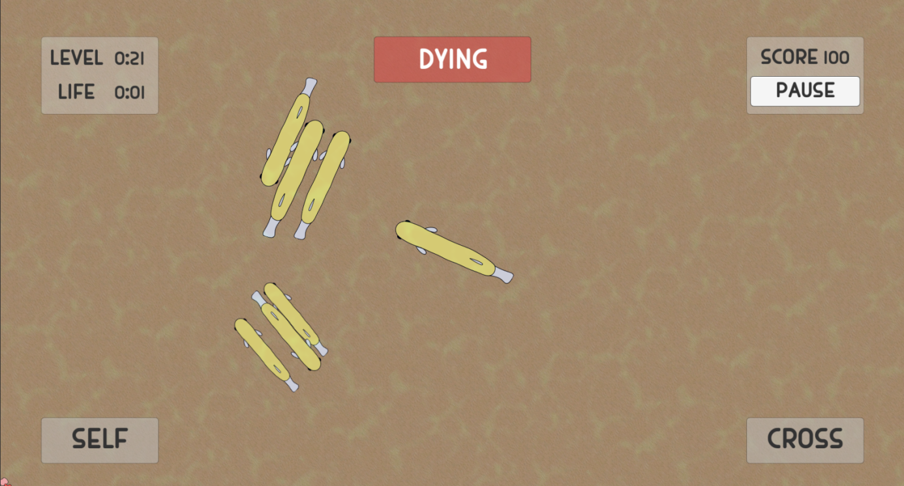

Fig1. The act of performing self-fertilising

## Specification

### Requirements

In order for the game to work as planned, there are features that is a must have and should have, and will be a cherry on top for could have, these features will be seperated into 2 groups: functinoal and non-functional.

#### 3.1.1 Functional Requirements

Features including:

1. A Working pause and unpause button
2. A timer for when the game ends.
3. A timer for when the fish’s life reach its end.
4. The initial spawn of player
5. The initial spawn of NPC fish
6. The initial spawn of food
7. The initial spawn of pathogens
8. The Control of spawns when the number of pathogens or temperature floats
9. The Control of player.
10. The buttons of self-fertilising and outcrossing
11. The spawns of self-fertilising and outcrossing
12. The interaction between player and pathogens with or without immunity.
13. Passing the control to one of the offspring if possible when the player die.
14. Level selection.
15. A working UI
16. A working Multiplayer.
17. Data generation and exportation.

#### 3.1.2 Non-Functional Requirements

Features including:

1. Maintain stable performance throughout the whole game.
2. Accurate simulation that is close to real world.
3. Graphics

### Problems to anticipate

One of the bigger problem to anticipate is to adding new factor into the game pool, as it will affect tons and tons of function changes, one miss step and it will be hours of figuring out what went wrong, such as no change happened, some other stuff that is not suppose to change changed or even crashing.

Another problem to anticipate is the correctness of data collection, if the sampling time is too large it might miss some sudden changes or the data ouput in the wrong format etc.

### 

### Tool to use

#### 3.3.1 Unity

For this study Unity is favoured as it is one of the popular game engine, as well as what the implementation run on, additionally it support a variety of desktop, mobile, console and virtual reality platforms, the large community of Unity also allow a great chance on providing ideas when oneself is stuck on technically problems, favoring both new comers and veteran.

#### 3.3.2 Bluestacks

As one of the most popular emulator, bluestacks allow the run of .apk files on desktop, conveniently simulating the environment of running on a tablet, it also contain a variety of different performance selection, making simulating on a low-end environment much easier.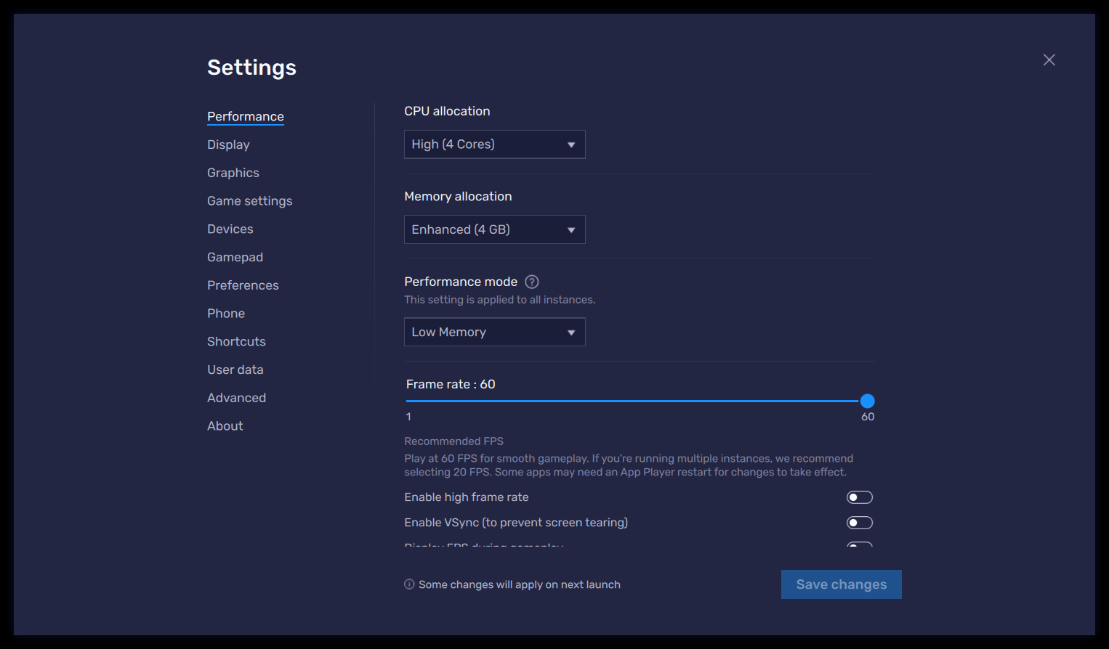

Fig.2. Performance setting of bluestacks

## Planning

Work on temperature, custom scenario and get data out as spreadsheet.

Unfortunately planning is severely limited by my lack of ability to plan plans ahead.

## References

1. Wikipedia page of Mangrove rivulus, URL: https://en.wikipedia.org/wiki/Mangrove_rivulus